

FALCON FIRE PROTECTION DISTRICT
Fire Prevention Division
7030 Old Meridian Road
Falcon, Colorado 80831
Business Number: 719-495-4050 Business Fax: 719-495-3112



WATER SUPPLIES FOR FIRE PROTECTION

General requirements per the Locally Amended 2021 International Fire Code (IFC)

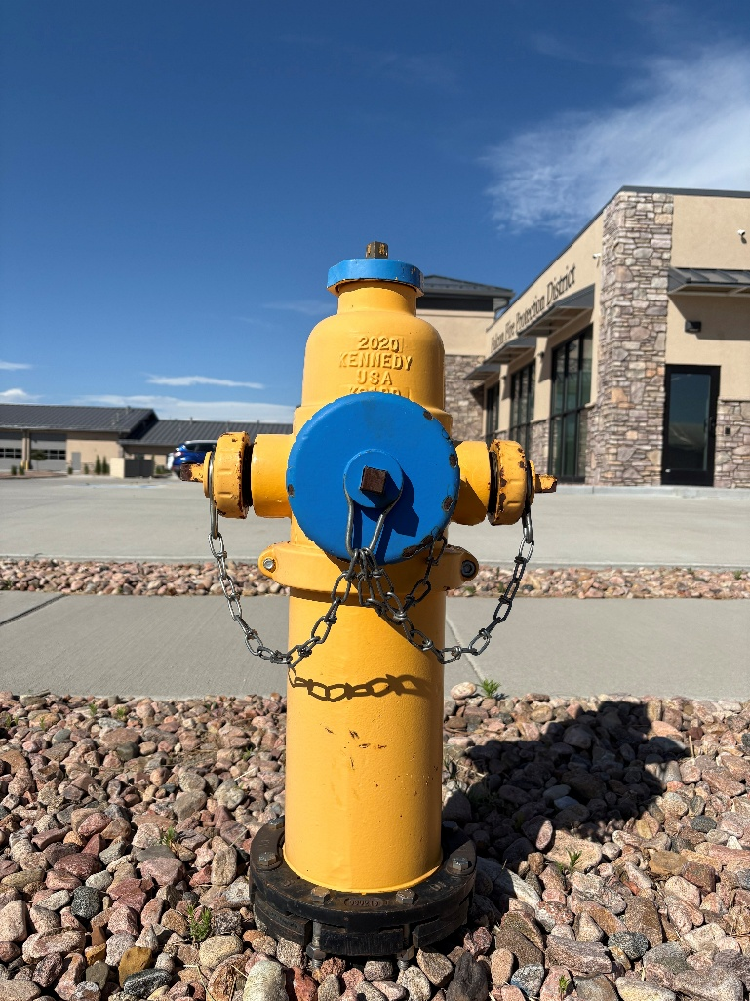

UNDERGROUND FIRELINE REQUIREMENTS

Key Requirements
- Submit water plans for FFPD review and approval before installing hydrants, fire department connections, fire lines, or related water supply infrastructure.
- Include a current fire flow report, building data, hydrant locations, FDC location, water supply feeds, valves, and required plan review information with each applicable submittal.
- Use a State of Colorado-registered Fire Suppression System Contractor—Underground for fire line installation, and secure required FFPD inspections before underground work is covered.
- Coordinate FFPD and local water district requirements early because both agencies review water plans involving new or relocated hydrants and new fire line service.

Purpose

This guidance document provides Falcon Fire Protection District customers with clear requirements for fire protection water supply review. FFPD and local water districts work together to review water plans for adequate fire flow, hydrant location, and hydrant quantity. The goal of these reviews is to confirm that proposed water systems meet the minimum requirements adopted by the Falcon Fire Protection District.

Scope

This guidance document outlines requirements from the adopted International Fire Code, local amendments, departmental policies, and applicable NFPA standards for the installation of fire hydrants and fire lines serving commercial and residential occupancies with access to local water district supplies. It also identifies information that must be included on working drawings and supporting documents. This document is not an all-inclusive list of submittal and inspection requirements, because project conditions may vary.

Definitions

AHJ Authority Having Jurisdiction
FFPD Falcon Fire Protection District
FDC Fire Department Connection
Fire Flow Calculation Area The gross square footage of all floors.
Fire Flow The rate of water in GPM measured at 20 psi residual pressure.
Fire Line The portion of underground pipe from the water main to a building that is dedicated to the fire sprinkler system.
Ft2 Square Feet
GPM Gallons per Minute
IBC International Building Code
IFC International Fire Code
NFPA National Fire Protection Association
PIV Post Indicator Valve
PSI Pounds per square inch

Guidelines

- Introduction

- Applicable Codes, Standards and State Statutes & Regulations
  - 2021 International Fire Code and its local Amendments
  - NFPA 24 Installation of Private Fire Service Mains and Their Appurtenances
  - FFPD Administrative Rulings and Interpretations

- Administrative Requirements
  - Approved Contractors. All fire lines must be installed by contractors who are registered with the State of Colorado as a “Fire Suppression System Contractor – Underground.” Per 8 CCR 1507-11 & C.R.S 24-33.5-1202. Please contact the Colorado Division of Fire Prevention and Control at 303-239-4600 for additional information on obtaining this registration.
  - Code/Standard Editions. All water system designs shall meet the criteria of the adopted IFC as amended and all applicable requirements of the most recent edition of NFPA 24. NFPA standards are effective on January 1st of the year following the effective date printed in the standard.
  - Plan Reviews/Inspections. Required plan submittal with approvals and associated inspections must be secured through FFPD. This is in addition to the review and inspections conducted by the local water district.
  - Revisions. All revisions shall be clouded and identified with a sequential numbering or lettering system, such as Revision A, B, etc. or Revision 1, 2, etc. Revisions are date sensitive; thus, each revised sheet must bear the date of the revision.

- Submittal Information

Submittals must be clear, complete, and detailed enough to show the location, nature, and extent of the proposed work and demonstrate compliance with the IFC and other laws, ordinances, rules, and regulations adopted by the Falcon Fire Protection District. See the appendix checklist for required plan information. Contact the local water district for its submittal requirements. FFPD and the local water district conduct concurrent reviews of water plans involving new or relocated fire hydrants and new fire line service.

A. MINIMUM REQUIREMENTS

1. Drawing Size. Drawings shall be submitted electronically via the online portal. Plans shall be scaled or suitably dimensioned and reproducible. Plans shall contain the information and/or details indicated in the checklist in the appendix.
2. Number of Drawing Sets. Only one (1) copy is required when submitting electronically via the online portal. A stamped copy will be returned to the contractor after approval.
3. FFPD Plan Review Application. Fill out the plan review application form and attach to all submittals. www.falconfirepd.org
4. Fire Flow Report. Fire flow reports older than 1 year will not be accepted. Reports must be obtained from the local water district or outside jurisdictions, as necessary.
5. Tax Schedule Number. Drawings shall be provided with the Tax Schedule Number found on the approved development plan or through the El Paso County Tax Assessor.
6. Signature Block. When all requirements have been met, the water plans will be signed off by this office. The following must be included on plans along with space to provide an electronic stamp:

FFPD ACCEPTANCE All Fire Hydrants shall be installed according to the local water district water line extension and service standards. The number of fire hydrants and hydrant locations as shown on this water plan are correct and adequate to satisfy the fire protection requirements as specified by the Falcon Fire Protection District.

Signed: __________________________________________
FFPD Fire Prevention Division

FFPD Plan Review Number: _________________________

7. Building Data. At the very minimum, you must supply the Fire Flow calculation area and the construction type of the building. The fire flow calculation area is the total floor area of all floors within the exterior walls, and under the horizontal projections of the roof of the building (IFC Appendix B104.1). Before we approve the plans for signature, you must provide all the following information on the plans:
a. Building Name
b. Address, if known
c. Gross Square Footage
d. Construction Type
e. Fire Sprinklers: Y N (If Yes, SHOW 50% REDUCTION DATA)
f. Required Fire Flow
g. Minimum # of hydrants required
h. Maximum Average Spacing
i. Maximum Hose Lay

- PRELIMINARY REVIEW ON THE DEVELOPMENT PLAN

FFPD may review hydrant placement and the required number of hydrants during the development plan review stage, if specifically requested. Provide, at a minimum, the construction type and square footage for this preliminary review. Hydrants, FDCs, and water lines may not be installed until the water plans have been signed by both FFPD and the local water district.

- GENERAL INFORMATION AND REQUIREMENTS

- FIRE FLOW. Determine fire flow requirements by applying Appendices B and C of the adopted IFC to the building in question. At a minimum, identify the building construction type and fire flow calculation area. For worst-case planning, use Type V-B construction with the building area. Do not submit only the building footprint area. Fire flow reports older than one year will not be accepted and must be obtained from the local water district.

- Type of Construction. The type of construction that the architect has assigned to the structure must be indicated on the plans. Be sure you have reconciled with the architect – differences in construction type can have a significant impact on required fire flow resulting in an underdesigned distribution system.

2. Fire Flow Calculation Area. The area to be considered in determining the fire flow for these buildings shall be the total floor area of all floors within the exterior walls, and under the horizontal projections of the roof of the building (IFC Appendix B104.1). For type IA and IB construction, it is the three largest consecutive floors. NOTE: Fire walls with openings, whether protected or not, cannot be used to reduce the fire flow calculation area IFC B104.2.

3. Fire Sprinklers. A 50% reduction in fire flow is allowed with the use of a fire sprinkler system, whether they are required or not. For example, if your building requires 5000 GPM by the table, and the building is sprinklered, the required fire flow may be reduced to 2500 GPM. Your required number of hydrants and spacing will be determined by the reduced fire flow. The minimum flow accepted is 1500 GPM. When reducing the fire flows, you will occasionally end up with an odd number such as 1825, in these cases you must round up to the nearest 250 GPM.

4. Simultaneous Fire Flows. If you do not meet the required fire flow, FFPD accepts the practice of using multiple hydrants that are open simultaneously to determine available fire flow. Models for this can be requested through the local water district.

5. Alternatives. If the required fire flow still cannot be met by any reasonable means (changing construction type, increasing pipe sizes, looping mains) there are alternatives that may be considered.
a. Fire sprinkler systems, if not already provided, may allow for a 50% reduction in required fire flow.
b. Request a simultaneous fire flow report.
c. Reduce the size of the building.
d. Fire walls constructed in accordance with the adopted IBC create separate buildings. Note: fire walls cannot have openings.
e. On site stored water with an automatic pump supply providing the required fire flow and duration.
f. Actual flow test of existing hydrants.

6. Reminders.
a. 1,500 gallons per minute (GPM) at 20 psi is the minimum flow and pressure permitted for both residential and commercial sites when hydrants are flowing individually.
b. 750 GPM at 20 psi is the minimum flow and pressure permitted per hydrant for both residential and commercial sites when hydrants are flowing simultaneously.
c. “On site/actual” fire flows dated less than five years is an acceptable alternative to a theoretical report from the local water district, at the time of plan review. These actual fire flows must be provided with the flow at 20 psi.

- HYDRANTS. The primary purpose of fire hydrants is to supply water to firefighting apparatus. The proper location, operation and system capability is essential to the successful execution of fire department operations during an emergency. Providing appropriate water flow is the responsibility of the developer or property owner. These systems must meet FFPD and local water district standards and gain approvals prior to installation.

1. Existing Hydrants. Label all existing hydrants with the local water district number.

- Private Hydrants. Private hydrants become the ultimate responsibility of the property owner with regards to maintenance and repair. They must be flow tested and painted prior to issuance of a Certificate of Occupancy. Should the property owner not be willing to undertake this responsibility, it is strongly recommended they seek a solution with the local water district to allow the installation of public hydrants. Use of a private hydrant owned by another property owner requires the use of a Private Hydrant Agreement. This is a legal document and must be registered through the El Paso County Clerk and Recorder’s Office. FFPD does not need to be involved in this process.

3. Placement.
a. Hydrants should be placed at intersections for increased flexibility. Where this is not possible, it may be placed along a curb or in a parking lot island. Access and turning radius must always be in consideration.
b. Hydrants must face the direction of water flow i.e., the lateral line they are connected to. Keep this in mind when laying the water mains, as the large diameter outlet connection on the hydrant must face the street.
c. In most cases, fire hydrants should be on the same side of the street that the building is located on. Having to lay hose across streets or driveways could inhibit access for additional fire apparatus.
d. Avoid putting hydrants at the end of dead-end streets or cul-de-sacs.
e. Hydrants shall be located so that the center of the large diameter outlet is not less than 18-inches above final grade, and not more than 36-inches above grade.
f. Hydrants shall not be located behind obstructions such as parked cars, fences, retaining walls, trash enclosures, planters, etc.
g. Fire hydrants should be located a minimum of 40 feet from any building to ensure they remain outside the collapse zone.
h. A 3-foot clearance is required around all hydrants.

4. Spacing. Hydrants shall be located with the following considerations in mind:
a. Meet the requirements of Appendix C of the adopted IFC (See Appendixes) for location and distribution.
b. For sprinkled buildings, the FDC shall be located within 100 feet of a fire hydrant and be located on the street side of the building. If this cannot be accomplished due to unusual site configurations or existing infrastructure, please call the Fire Marshal (FFPD) to discuss potential solutions.

  - Protection from Vehicular Damage. Posts or concrete barriers may be used to protect hydrants from vehicular damage. Please refer to our guidance document titled “Protection of Equipment from Vehicular Damage” for additional requirements.

C. FIRE LINES.
1. Fire lines shall be installed by an underground contractor registered with the State of Colorado as a “Fire Suppression Contractor – Underground.”
2. The minimum size of a fire line for a commercial building is typically 4-inches. If a smaller size is desired, it must be hydraulically proven to provide the necessary water supply for the fire sprinkler system.
3. Fire lines must be flushed and hydrostatically tested prior to the connection of any above-ground piping. Be advised the chlorination flush performed by the local water district does not satisfy the requirements of the FFPD for flushing the fire lines, as it is not at the velocity or volume required by NFPA. Keep in mind if a fire pump is to be installed; the required flushing velocity is 20 feet per second. Consult NFPA 20, Chapter 14 for these required flow rates.
4. Fire Lines shall also be hydrostatically tested at a minimum of 200 psi or 50 psi over the static pressure for a minimum of 2 hours.
5. Fire lines shall NOT be run underneath buildings!

NOTE: The installing contractor is responsible for completing the required “Contractor’s Materials & Test Certificate for Underground Piping per NFPA 24. This form must be completed and signed prior to the inspector arriving on site for the inspection.

D. FIRE DEPARTMENT CONNECTIONS (FDC). Fire department connections provide a means for FFPD to supplement the water supply to a fire sprinkler system. By considering the location of the FDC at the water plan stage, all parties involved can prepare for this requirement.
1. FDCs shall be located with the following considerations in mind:
a. On the main entrance and/or the street side of the building.
b. Cannot be obstructed by parking, landscaping, planters, columns, fences, retaining walls, etc.
c. A 3-foot radius of clearance shall be provided around the FDC to provide for our hose connections.
d. Within 100-feet of a hydrant.
e. Within 40-feet of a fire department access road.
f. Away from and on a separate wall from any utility meters.
2. FDCs shall be mounted not less than 18 inches and not more than 4 feet above the adjacent grade or access level.
3. If a remote FDC is installed, the submitted water plans must show that an outside horn/strobe unit will be provided in a highly visible and acceptable location within 20 feet of the FDC. NOTE: Remote FDC piping is not inspected by the local water districts. This piping must be inspected by FFPD before burial.

E. FIRE WALLS. In buildings utilizing fire walls, it is important that they be listed slightly differently in the building data block, than normally utilized.
1. Please use this format, and list each structure as follows:
Business Name
Business Address
Tax ID Number
Total Gross Square Footage of Building
Ratings of Fire Walls Being Installed

Building A Building B
Type of Construction Type of Construction
Square Footage Square Footage
Fire Sprinklers Fire Sprinklers
Required Fire Flow Required Fire Flow
Min # Hydrants Min # Hydrants
Max Average Spacing Max Average Spacing
Max Hose Lay Max Hose Lay

- Fire walls shall be not less than 2-hour fire-resistance rated. These walls are not allowed to have openings (including protected openings) in order to be considered for reducing the fire flow requirements. Most buildings need to have openings in these fire walls for their operations, making this a less than desirable method to reduce building size.

F. DEAD END SERVICE LINES. Unless approved by the fire code official, dead end fire service mains shall not be used when there is not a reliable secondary or redundant means of water supply within 500 feet of a structure along an approved route.

Links

Colorado Division of Fire Prevention and Control Web site.
https://dfpc.colorado.gov/

Appendices

- FFPD Submittal Checklist
- Appendices B and C of the Adopted IFC

APPENDIX A - FFPD SUBMITTAL CHECKLIST

HYDRANTS & WATER MAINS

The following must be included on all plans to ensure a complete submittal. Specific details for each item are found in this packet:

❑ Include completed FFPD Plan Review Application
❑ Include Fire Flow Report from the local water district with map (not required for USP)
❑ Include all red-lined plans for re-reviews when requested
❑ Development Plan must be approved by FFPD before water plans can be signed
❑ Provide FFPD Plan Review Number on cover sheet
❑ Provide FFPD Signature Block on cover sheet
❑ Provide El Paso County Tax ID Number
❑ Provide Building Data, if required (not required for utility service plan only)
❑ Provide local Water District Map Page Numbers
❑ Show Fire Department Connection (FDC) location, if applicable
❑ Show Water Supply Feeds for the sprinklers, standpipes, domestic water systems, all valves, including post indicator valves
❑ Show tie-ins to all existing water lines
❑ Label new and existing hydrants with local water district number and fire flow, ensure numbers match flow report
❑ Label all hydrants and water mains as public or private
❑ Label all streets with name and/or proposed name
❑ For gates, fences, and walls: show how FFPD will gain access on fire lanes and around building
❑ Provide Service Line Integrity Statement on cover sheet, if applicable

APPENDIX B

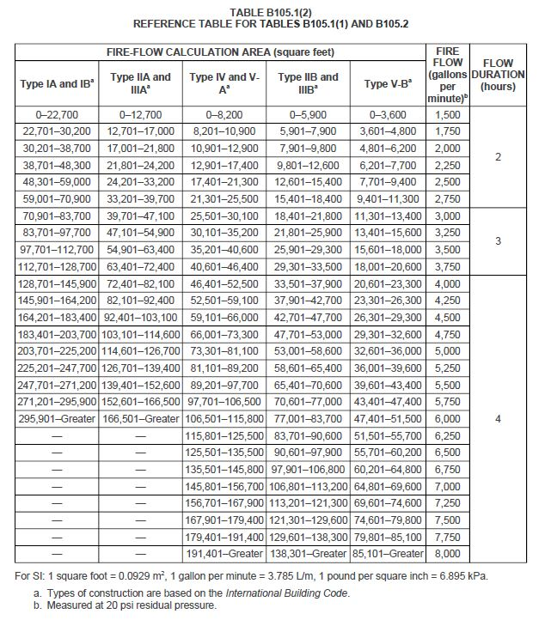
Exception: A reduction in required fire-flow of 50 percent, as approved, is allowed when the building is equipped with an approved automatic sprinkler system.

APPENDIX C

