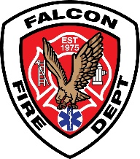

**FALCON FIRE PROTECTION DISTRICT**

Fire Prevention Division

7030 Old Meridian Road

Falcon, Colorado 80831

Business Number: 719-495-4050 Business Fax: 719-495-3112

www.falconfirepd.org



Rapid Entry System

KNOX-BOX®

The Falcon Fire Protection District requires a locking KNOX key box on all commercial buildings as defined by the Fire Code Official, or where immediate access is necessary for life-saving or firefighting purposes per the 2021 International Fire Code, Section 506.1, 5.6.1.1 and 912.4.1.

506.1 Where required.Where access to or within a structure or an area is restricted because of secured openings or where immediate access is necessary for lifesaving, or fire-fighting purposes, or where monitored fire protection systems or elevators exist in the building, the fire code official is authorized to require a key box to be installed in an approved location. The key box shall be of an approved type listed in accordance with UL 1037 and shall contain keys to gain necessary access as required by the fire code official.

**LOCATION:** The KNOX key box shall be located at the “main front entrance” of the building at five (5) feet above the finished grade.

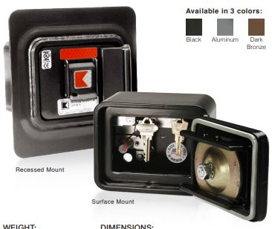

Multi-Tenant Buildings – A KNOX box may be installed at each tenant entrance or a single box may be installed at the far-right side of the building as you are looking at the store fronts, mount the box at five (5) feet above the finished grade. If this method is used, please ensure you order a key box large enough to accommodate two sets of keys from each tenant space.

**DECALS:** The KNOX decal shall be installed at the main front entrance or as required by the Fire Code Official.

**BUILDING KEYS:** The box shall contain at least two (2) sets of labeled keys, including but not limited to: keys for access into and through the premises, keys to any secured fire protection system, and elevator keys.

**MAINTENANCE:** The Operator of the building shall immediately notify the Fire Code Official and provide new keys when a lock is changed or rekeyed.

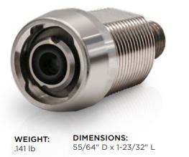

**eLOCK RETROFIT CORES:** Approved KNOX retrofit cores. Powered by the Knox eKey®, the Knox eLock Core is constructed of brass to withstand physical stress and the harshest weather conditions. The patented non-contact design protects the core from dust and dirt and can be retrofitted into most existing Knox mechanical products.

BENEFITS:

• Maintenance-free protection against dust and dirt.

• Lock code can be easily updated to accommodate jurisdiction boundary changes

• Can be retrofitted into most existing Knox mechanical products

FEATURES:

• Eliminates physical rekey for lock code change

• Requires no wiring or batteries for power

• Stores up to 140 events • Holds 1 lock code • Power provided by the Knox eKey

• Stores firmware

• Provides access information by date and time

• Patented non-contact design

• Built Knox-Rugged, constructed of brass

• Operating temperature: -40° to +60° C • Storage temperature: -40° to +80° C

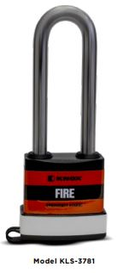

**GATE/BARRIER LOCKS:** Approved KNOX padlocks shall be installed in gates or similar barriers when required by the Fire Code Official per the 2021 International Fire Code, Section 506.1.1.

506.1.1 Locks.An approvedlock shall be installed on gates or similar barriers where required

by the fire code official.

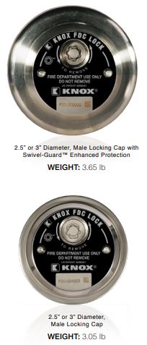

**LOCKING FIRE DEPARTMENT CONNECTION (FDC) CAPS:** Fire Department Connections shall be secured with KNOX FDC Caps in accordance with the 2021 International Fire Code, Section 912.4.1.

912.4.1 Locking fire department connection caps.The fire code officialis authorized to require locking caps on fire department connections for water-based fire protection systems where the responding fire department carries appropriate key wrenches for removal.

**COMMONLY USED PRODUCTS:**

|  |  |  |
| --- | --- | --- |
| **PRODUCT** | **MODEL** | **SPECIAL INFORMATION** |
| **Surface Mount Box** | **KLS-3200** | **No Tamper Switch Required** |
| **Recessed Mount Box** | **KLS-3200** | **No Tamper Switch Required** |
| **Surface Mount Box** | **KLS-4400** | **No Tamper Switch Required** |
| **Recessed Mount Box** | **KLS-4400** | **No Tamper Switch Required** |
| **Exterior Padlock** | **KLS-3781** | **N/A** |
| **Locking FDC Cap** | **3110 or 3111** | **N/A** |
| **eLOCK Retrofit Cores** | **KLS-8800L** | **N/A** |

**ORDERING:** You can now order KNOX equipment on-line by simply selecting “Online Purchase” from the KNOX Company homepage at: [info@knoxbox.com](mailto:info@knoxbox.com), 800-552-5669 or from SENTRY TECHNOLOGY PRODUCTS at 720-710-5669 (Denver, CO). Please contact Lieutenant/Fire Inspector Curtis Kauffman (Fire Prevention Division) prior to ordering any Knox products. **All KNOX** equipment will be shipped to the Falcon Fire Protection District office and you will be notified when it is available for pickup.